BUDHA DAL PUBLIC SCHOOL, SAMANA
LESSON PLAN
CLASS - IX
SUBJECT - MATHEMATICS
SYLLABUS - TERM - I

Name of Teacher: Ms. Nisha Verma

TERM - I

Chapter 1 - Number System
Chapter 2 - Polynomials
Chapter 3 - Coordinate Geometry
Chapter 4 - Linear Equation in one variable
Chapter 5 - Erclid Geometry
Chapter 6 - Lines and Angles
Chapter 7 - Triangles
Chapter 12 - Heron's Formula
Chapter 13 - Surface Areas and Volume
Chapter 14 - Statistics
Chapter 15 - Probability

TERM - II

Chapter 8 - Quadrilaterals
Chapter 9 - Parallelograms
Chapter 10 - Circles
Chapter 11 - Constructions

Topic - Number System

P. K. Testing | - What do you understand by Natural no. whole nos, integers and rational nos.  - How will you express 36/100 in decimal form?  - What will be the decimal representation of $\sqrt{2}$ ?
Learning Objectives | - To explain real number system.  - Extend students concept beyond integers and define.  - Rational no. and irrational no.  - Find rational nos. between any two rational nos. and irrational.
Contents | - Introduction to number system.  - Explanation of irrational nos.  - Real numbers and their decimal expansions.  - Representing real nos. on the number line.  - Operations on rational and irrational nos.  - Laws of exponent and their applications
Art integrated Activity | Students will perform of irrational numbers by representing then on number line. For the concept clarity of irrational no. videos from Diksha App. will be sent to students.
Home Work | Ex - 1.1, 1.2, 1.3, 1.5, 1.6 Will be given from NCERT as homework.

Topic - Polynomials

P. K. Testing | - What do you call an expression having two terms?  - What do you understand by the degree of a polynomial?  - Differentiate between a polynomial and an equation.  - How many solutions are there for a linear polynomial?
Learning Objectives | - Knowledge of zeroes of a polynomial.  - To apply remainder theorem and factor theorem.  - To factorise quadratic and cubic polynomial.  - Applications of Algebraic Identities.
Contents | - Polynomials in one variable.  - Zeroes of the polynomial.  - Remainder theorem  - Factor theorem  - Factorization of polynomials  - Algebraic Identities
Art integrated Activity | Students will perform an activity to do factorization of quadratic equation by using paper of different colours strips to represent variables and constant term. Link provided to them to do activity is https://youtube/wPDr.NWikmy.
Home Work | Ex - 2.1, 2.2, 2.3, 2.4, 2.5 questions will be given to students as homework.

Topic - Coordinate Geometry

P. K. Testing | - What are horizontal and vertical lines?  - Suggest some integers which lie on left side of No. line.
Learning Objectives | - To make students aware of the Cartesian plane.  - To provide knowledge about quadrants.  - Location of coordinate in Cartesian plane.  - Plotting of coordinates in XY plane.
Contents | - Cartesian Plane.  - Plotting a point on the plane.  - The quadrants in which a point lies.  - The axes on which point lies.  - Knowledge of origin, abscissa, ordinate and four quadrants.
Art integrated Activity | Students will perform an activity of seating plan in which they find the position of particular child. The video from Diksha App will shown to students for the concept clarity link.
Home Work | Ex - 3.2, 3.3 questions will be given to students as homework.

Topic - Linear Equation in two variables

P. K. Testing | - What do you understand by linear equation?  - How many variables are there in 2x + 3y = 5?  - In above equation if we put x = 0, the y =?
Learning Objectives | - Introduction to linear equation in two variables.  - To find the solution of a linear equation in 2 variables.  - Graphical representation of Linear equations
Contents | - Standard linear equation in two variables ax + by + c = 0  - Graph of linear equation in two variables.  - Graphs of equations of the type x = a (Parallel to x - axis)  - Graphs of equations of the type y = b (Parallel to y - axis)
Art integrated Activity | Students will make an activity of balancing the equations by putting different values of variables x and y. Link provided to them to do activity is https://youtube.IN20VrPmxdk.
Home Work | Assignment will be given in home work.

Topic - Introduction to Euclid's Geometry

P. K. Testing | - What is Geometry?  - Can you define a point, a line or a surface?  - What do you understand by tem Axions, postulates and Theorems?
Learning Objectives | - To make students familiar with Euclid Axion and Postulates to solve various problems and define various terms.
Contents | - Euclid's 7 axions  - Euclid's 5 postulates  - Application of Euclid's geometry to solve questions.  - A special attention towards Euclid's 5th postulate.
Art integrated Activity | Students will perform the activity to show that whole is always greater than its part. In this, they make a circle and divides into six equal parts. Firstly, they find area of circle and then area of sector. In last they compare the area's in which they get area of circle is greater than area of sector.
Home Work | Questions of Ex. 5.1 and 5.2 will be given in homework.

Topic - Lines and Angles

P. K. Testing | - What are vertical opposite angles?  - What are transversal lines?  - What are alternate angles?
Learning Objectives | - Recall basic term and definition of geometry.  - Distinguish between the different types of points and lines.  - Identify different types of angles and its pairs.
Contents | - Introduction  - Basic terms and definitions  - Intersecting and non - intersecting lines.  - Pairs of angles.  - Parallel lines and Trans versal.  - Lines parallel to the same line.
Art integrated Activity | Students will make a model for showing the properties of lines and angles. Link will be shared with students to help them. Link is http://youtube/Vovz2umndll
Home Work | Sums of Ex.- 6.1 and 6.2 will be given in homework.

Topic - Triangles

P. K. Testing | - What is the relation between two triangles of same?  - Shape and same size?  - Can two triangles be congruent if their areas are equal?
Learning Objectives | - More examples on Congruence.  - Revision of congruence conditions.  - Various techniques to make two triangles congruent.  - To make students familiar about in equalities in triangles.
Contents | - Conditions for congruence of two triangles SSS, SAS, Rtts.  - Sides opposite to equal angles are equal and angles opposite to equal sides are equal.  - Median of a triangle divides it into two triangles are equal in area.
Art integrated Activity | Studetns are given different objects of different size and shape. Teacher will ask the students to find congruent objects from stuff given to them. Link from diksha app will be sent to students to clear the concept of congruency of triangles. Linkhttps://diskha.gov.in.
Home Work | Sums of Ex. 7.1, 7.2, 7.3 and 7.4 will be given to students as homework.

Topic - Heron's Formula

P. K. Testing | - How to find the area of triangle if its base and height given.  - What is the perimeter of a triangle?  - What is the semi - perimeter of a triangle?
Learning Objectives | - How to find area of triangle when all the three sides are known to us.  - How to find the area of quadrilateral?
Contents | - Area of triangle = $\sqrt{S \left(s-a\right)\left(s-b\right)(s-c)}$  Here S = semi perimeter = a + b + c  2  - Area of quad. by dividing it into two triangles and then apply Heron's formula to find area of each triangle.
Art integrated Activity | Students will perform an activity by taking a case of different types of field to find its area. Link provided to them is https"//youtube/vMU4UJSV8r8.
Home Work | Questions of Ex.- 12.1 and 12.2 and assignment will be given in homework.

Topic - Surface Areas and Volumes

P. K. Testing | - What is area of square and rectangle?  - What is area of circle?  - How many faces does a cuboid have?
Learning Objectives | - Surface Areas and volumes of the object in the following shapes:- cube, cuboid, cylinder, cone, sphere and hemisphere.
Contents | 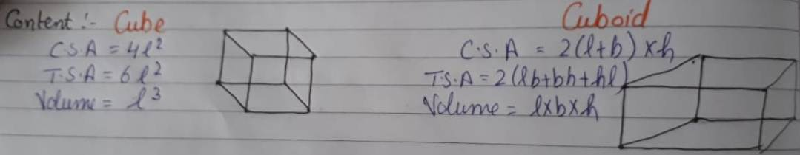  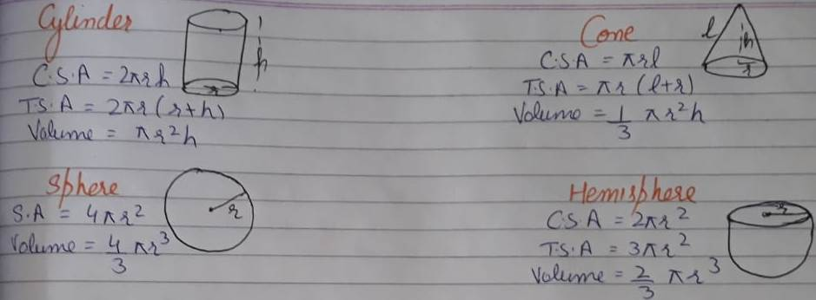
Art integrated Activity | Students will perform an activity by collecting different objects similar to these 3 - D shapes from their daily life objects and find its area and volume. Vedas will be shown to students to clarify the concept from Diksha app.
Home Work | Questions of Ex.- 13.1 to 13.8 will be given in homework.

Topic - Statistics

P. K. Testing | - What is the formula to find mean for raw data?  - Which is the middle value if five numbers are arranged in ascending order.
Learning Objectives | - Measures of central tenclency:- Mean, Median and Mode  - Frequency Distribution of Raw data  - Graphical Representation of data.  - Bar Graph, Histogram, frequency polygon.
Contents | Mean - Sum of Observations [For Raw Data]  No. of Observations  Mean - ∑ fi xi [ For Grouped Data]  ∑ fi  Median:- $\left({n+1 \atop 2}\right)$th observation [when n = odd]  Median:- $\left({n \atop 2}\right)$th + $\left({n \atop 2}+ 1\right)$th observations [when n = even]  2  Mode:- Most frequently occurring value of the data.
Art integrated Activity | Students will be assigned a project on statistics in which they find Mean, Median, Mode for Data. To help them with project some links will be sent to them  Links are :- https://youtube/QW - WKntoziE  https:// diksha.gov.in
Home Work | Ex.- 14.1, 14.2, 14.3 and 14.4 sums will be given in homework.

Topic - Probability

P. K. Testing | - How many sides does coin have?  - How many faces does a die have and what are numbers?  - If I have 5 red balls and 4 white balls. What is ratio?
Learning Objectives | - The meaning and formula of Probability.  - To apply probability concepts on various games of chance.  - To apply probability in real life.
Contents | - P (E) stands for probability of event 'E'  - P (E) = No. of favorable outcomes  Total outcomes  - 0 $≤$ P (E) $≤$ 1  - P (not E) = 1 - P (E)  - Sum of all probabilities is 1
Art integrated Activity | Students will perform of fun activity to find the probability of given outcomes.  Links given to them are:- https://youtube/ty Axr Vadtus.
Home Work | Sums of Ex. 15.1 and assignment will be given to students as home work.

